DEAKIN ENERGY – A GENERAL OVERVIEW

**OBJECTIVE**:

To create a Web application that forecast the energy demand and RRP(Regional Reference Price) for the state of Victoria using the historical data obtained from Australian Energy Market Operator (aemo.com.au)

**Dataset:**

It is a time series data with 30 minutes interval between them. Dataset contains Settlement data, Total Demand and RRP



* For our energy demand prediction, only Settlement date and Total Demand are taken into consideration.
* For RRP demand prediction, only Settlement date and RRP are taken into consideration.

**SKILLS REQUIRED:**

Backend- Python

Front end- Flask, HTML, CSS

**PROGRESS:**During the previous Trimester, the team was split into Front-end and Back-end sub teams based on their interest and forte. Further, the entire squad was assigned a task based on the sub team, the individual work over the tasks assigned was commendable.

* The Back-end team performed various forecasting models like ARIMA, Random forest regression, Linear regression, SVM, Decision Tree Regression and neural networks-LSTM over the Energy dataset.
* The Front-end team designed the Web application interface which provide features to either upload a Dataset or Choose amongst the Dataset present in the local machine and Accordingly forecast the energy demand.

**OUTPUT:**

Using the user interface, users have option to input the file or choose from the already existing files. Once the input file is chosen, the algorithm to execute must be selected from the dropdown button. On clicking ‘Train and Forecast’ button, the selected model will be trained on the input data and the model forecasted and actual values are displayed in the front-end screen using a line graph.

The image is obtained from the algorithms performed.

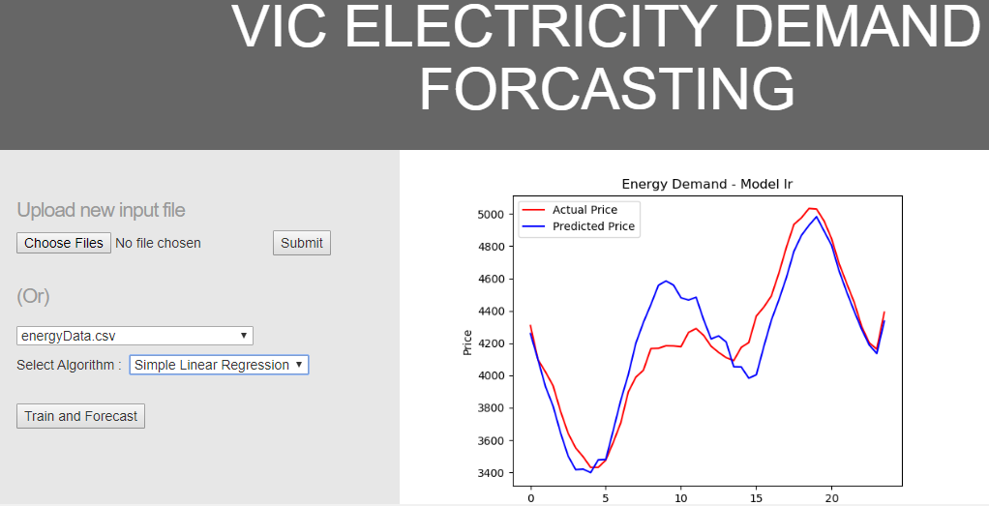

**Code:**



**Web Application:**

